CS3249 GUI Design Progress Report Microscope Team QX

Kit Wei Min A0115384 Wong Wei Jie Bob A0094718 Oh Qi Xuan A0096911

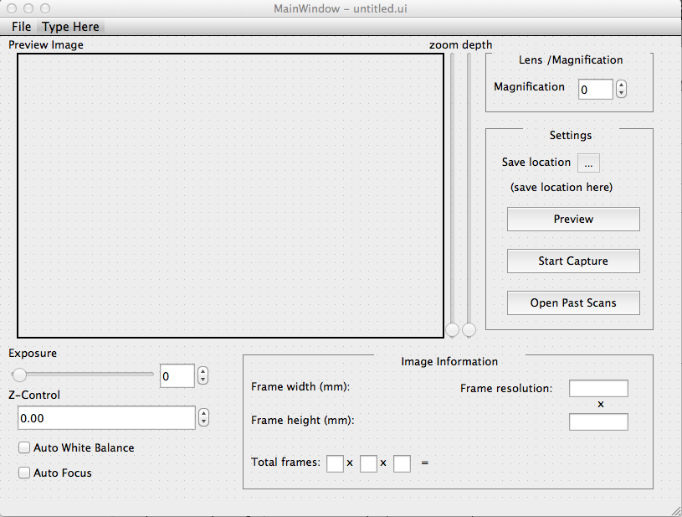

Based on the initial microscope design from tutorial 1, we are proposing a revamped GUI with several elements that emphasize aspects of the program important to the user, and de-emphasize lesser-used but still important elements.

First of all, instead of a large preview button, most of the space is taken up by a frame intended to contain the preview image. This frame updates only when the Preview button is pressed, to allow the user a fixed frame of reference when adjusting settings. We believe this is the main focus of the application and should be sized accordingly, as opposed to being assigned to another button as in the prior design. Allowing the frame to be in the same window as most of the application’s options enables fast review of changes. The frame is positioned on the upper left, as this allows it to be viewable easily at eye level as opposed to being positioned lower down, which may necessitate looking down at a slight incline and aggravate neck strain and user irritation.

Most users work with the typical layout where the mouse is on the right-hand side and the keyboard is on the left – as such, to facilitate mouse movement, often-used elements should be on the right, while rarely used ones should be on the left. Exposure, auto white balance and auto focus are three features which enhance the quality of the image to the user’s specifications; however, once set, they are seldom used afterwards. As such, these UI elements are relegated to the far bottom-left of the application, where they are non-obtrusive but still available to the user for information and modification.

Image information is located next to these options and below the image in a central position. Generally for UI elements, the center should deliver information instead of containing options. If options are arrayed on the edges of the application, it is easy for the user to swipe their mouse all the way to the left or right, as most OSes will restrain the mouse movement, allowing fast and efficient navigation of UI components. For non-modifiable, yet important information, it is thus satisfactory to position it in the center of the application, freeing up space on the sides of the application and drawing the user’s focus to it.

Magnification is located on the top right of the GUI, as an important but infrequently-used component. Though a slider may intuitively be an option, we believe that this would only introduce unnecessary clutter to the interface, as most uses of microscopes have different magnification options purely for versatility in perusing different samples, and do not require fast iteration through different magnification options. A spin box is sufficient to both allow modification of the magnification and display it.

Settings are located below magnification, and contains options to select save location and the buttons for Preview, Start Capture and Open Past Scans.

Selecting Start Capture will open up a dialog that informs the user that the scan is ongoing. Selecting Open Past Scans will open the file dialog for the user to select the folder storing the scans that the user is interested in. The following dialog box will then be opened.

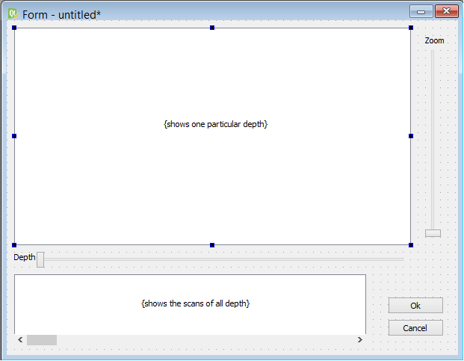

The main viewing window is again in the top left corner, and occupies the bulk of the dialog box. Sliders are used to zoom in on the image and to scroll through the different layers, though for advanced users, controls using the mouse and keyboard will be implemented as well. Users can also get a preview of all the different layers with the photo gallery located below the main viewing window, and can select a particular layer by clicking on the image as well.

This sums up the general GUI design.